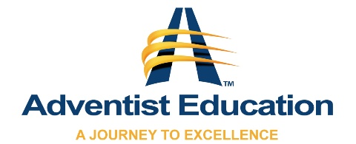
Teacher Name ______________________________ Date____________

Certification/Level __________________ Expiration Date____________

Continuing Educational Needs__________________________________
__________________________________________________________

Principal Recommendation for Teacher
2021-2022
Oregon Goal | Continuum of Growth
Christ-Centered Culture | - Struggles in relationships with students and/or parents  - Struggles to see potential in all children  - Minimal or no participation in advancing TAO opportunities for students | - Loves all students and families well  - Sees students as worthy  - Assists with school-wide TAO opportunities for students to serve | - Loves all students and families well  - Establishes a culture of worthiness and belonging  - Works collaboratively for students to serve their church and community | - Loves all students and families well  - Builds worthiness, belonging, & purpose in every student  - Creates opportunities for students to serve their church and community
Positive Choice & Restorative Relationships | - Struggles to demonstrate respect for all students  - Minimal or no opportunity for student choice in the learning process  - Uses punitive disciplinary processes rather than providing opportunity for restorative relationships | - Demonstrates respect for all students  - Provides students some choice in the learning process  - Follows restorative relationship practices | - Promotes a respectful culture among all students  - Bases classroom on student choice  - Incorporates restorative relationships in all decisions | - Mentors respect and confidence in all students  - Initiates intentional cultural changes for student choice  - Implements school-wide restorative relationships
Maximizing Individual Potential | - Minimal or no evidence of the 4 Cs in learning products  - Struggles to accommodate students with special needs  - Struggles to capitalize on student strengths to develop areas of growth | - Constructs learning products to sometimes incorporate the 4 Cs  - Implements at least one PBL unit  - Accommodates students with special needs  - Builds awareness of strength areas for each student | - Constructs learning products to incorporate the 4 Cs  - Implements at least two PBL units  - Uses UDL concepts to accommodate all learners  - Caters to the strengths of each student | - Constructs learning products to consistently incorporate the 4 Cs  - Consistently implements PBL units throughout the school year  - Structures class to optimize personalized learning  - Maximizes the potential leader in every student
Note: The lower category will apply in the overall rating if two or more items are circled in any one category.

- Based on an overall rating on the Continuum of Growth, I would like the Oregon Conference Board of Education to extend an invitation for ____________________________to continue their current teaching assignment for the 2019-2020 School Year.

- Based on an overall rating on the Continuum of Growth, I am documenting and working with _______________________ and my superintendent.

Principal Signature ______________________________________________________________ Date ______________________________________

